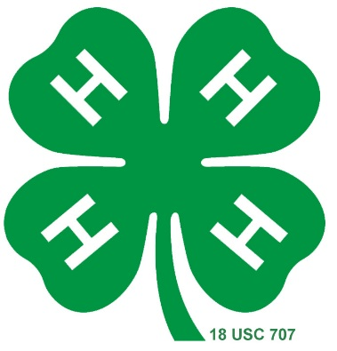
Head 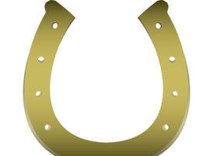 Heart Hands Health
Bridle Bunch
Hendricks County, Indiana 4-H Horse & Pony Club

2020 Bridle Bunch Family & Friends Sponsorship Form
Bridle Bunch desires to make the Hendricks County 4-H Fair an enjoyable event for all of our members. We are asking for a suggested donation of $25, but any amount will help sponsor Hendricks County 4-H Fair activities for Bridle Bunch members (prizes for competitions, daily treats, and other fun events) with any excess moneys being used for end-of-year club awards.
SPONSORSHIP FORM AND MONEY ARE DUE BY JULY 6, 2020. Please make checks payable to Bridle Bunch. Forms and money may be turned into club leaders or mailed to: Bridle Bunch, 1900 E Main St, Danville, IN 46122.

NAME: ______________________________________________________________________
4-H MEMBER REQUESTING SPONSORSHIP: _________________________________________
AMOUNT OF SPONSORSHIP: $________________

We thank you in advance for your support of the Bridle Bunch 4-H program and its members.
Adult Leaders,
Vicki Benge
Jennifer Buckingham

Your canceled check will serve as your receipt.

***If you or a business would be interested in sponsoring Grand Champion or Reserve Champion banners for our club, please contact Karla Smith at the Hendricks County extension office at KarlaSmith@purdue.edu.***

